

|  |
| --- |
| Customer Data Transformation Assessment (CDTA)  SQR1003830  Statement of Work  June 16, 2020 |

Table of Contents

1. Project Background 3

2. Scope of Work 5

3. Deliverables 7

4. Roles and Responsibilities 10

5. Proposed Assessment Timeline 14

6. Estimated Costs 15

7. Governance 17

8. Assumptions 20

This Statement of Work ("SOW”) is made and entered into as of June 22, 2020 (“SOW Effective Date”) by and between Capgemini America, Inc. (“Capgemini”) and National Grid USA Service Company, Inc. (“National Grid” or “Client”). By signing below, the parties agree to the terms and conditions of this SOW, which shall be governed by the Framework Agreement related to Applications Development and Applications Maintenance Services, dated December 17, 2018 (“Agreement”), between the parties. The terms and conditions of the Agreement are an integral part of this SOW and are hereby incorporated herein. Capitalized terms not defined herein shall have the definitions given to them in the Agreement.

1. Project Background
   1. Overview

|  |
| --- |
| **National Grid’s Customer Data Domain Objectives** |
| National Grid strives to define the data strategy for customer data to:   * Implement leading practices in Customer data Management through the enterprise for enablement, adoption, and compliance of published standards, policies and processes for collecting, structuring, validating, transforming, storing and visualizing enterprise-level, mastered, domain centric and transactional data, from which these insights and actionable intelligence will be gained. * Integrate and unify the Data Management process, Governance and Tools to reduce barriers, mitigate risk and create streamlined opportunities, and allow employees to efficiently and effectively respond to Stakeholder’s and Internal Information need and drive customer satisfaction. * Design Enterprise Data Management processes and tools by developing an operating model for data customer data management for customer data. * Establish and maintain governing standards to gain control and sustain the data ecosystem by leveraging quality assurance and preserving data accuracy, completeness, reliability, relevance, and timeliness. * Validate business data is accurate, available, relevant and current for both internal and external consumers, and that information across systems of record are consistent and reliable as a responsibility to the enterprise adhering to legal/regulatory compliance and protecting the reputation of the organization. * Achieve budgetary targets by driving efficiencies through transformation imperatives, innovations in technology approaches to achieve avoided costs associated with poor data quality and low governing maturity, and prioritization of enterprise data projects and work to deliver tangible value. * Ensure sufficient organizational competencies and capabilities to support current and targeted operational models for broad-based customer data management across the enterprise as a basis in delivering overarching strategic objectives. |
| **Without a data foundation, the digital transformation journey will be turbulent and at-risk to achieve desired program objectives** |
| * A robust data foundation is a prerequisite for all the promising technologies researched, considered, piloted or scaled in operations. * The importance of creating a data foundation for the organization cannot be understated to provide consistency, interoperability, quality, availability, and accessibility of data across multiple domains. * Leading industry practice serves as a benchmark to evaluate “as is” practice efficacy. * Alignment with Industry Standards promotes streamlined transition of domain knowledge into cohesive enterprise practices. * Critical enterprise-level compliance due diligence can occur concurrently with data transformation activities and supports OPEX cost avoidance. * Software selection processes are informed by National Grid mastered data inventories and data standards based on established MDM artifacts. |
| **Utility business models are changing to address IT operating model support of mission-critical priorities, evolving systems and actionable insights demands to fit future business needs.** |
| * Greater reliance on data to improve business insights and decision making requires utilities to shift from reactive to proactive, agile information and IT operating models that drive value across technology assets. * Investments in data as an asset support lower operating costs, drive value creation and equip the organization for a digital future. * Whether system integration requires technology consolidation or leveraging existing data structures and processes, mastering data must be a consideration at the onset to include:   + Develop detailed data ecosystem design to maximize the business value of data asset investments.   + Build necessary functionality, technology platform and data migration automation.   + Build and test data alignment and mapping to established governance and standard.   + Deploy data transformation cutover plan design and execution.   + Deploy quality assurance and controls as established during the design phase. |

* 1. Our Understanding

National Grid wishes to engage Capgemini to assess the current customer data domain to be able to provide a high-level logical model, conceptual model, data remediation scope, and ROM cost in support to achieve targeted data management objectives. The assessment will serve to build a data remediation roadmap. This will be accomplished through a phased approach of 1) Evaluation of existing customer service architecture and assessment materials, validate critical information and identify any gaps via stakeholder interviews, 2) future or “aspirational” state recommendations and 3) customer data transformation roadmap to include scoping effort to remediate data and provide a ROM Cost.

1. Scope of Work
   1. Data Management Key Focus Areas

* People and Culture: Abandon tool therapy as the first line of defense, concentrate on people, culture and data literacy first. Tooling does not solve data fitness, siloed activities, embedded complexity, undue bureaucracies or SME dependencies.
* Trust: Shift focus away from spreadsheets, tools and technology to fostering trust in and use of data.
* Governance: Establish and maintain governing standards to gain control and sustain data streams by leveraging quality assurance and preserving data accuracy, completeness, reliability, relevance, and timeliness.
* Process: Shape processes and frameworks to enable efficiencies and data integration across the enterprise.
* Accuracy: Ensure business data is accurate, available, relevant and current for both internal and external consumers, and that information across systems of record are consistent and reliable as a responsibility to the enterprise adhering to legal/regulatory compliance and protecting the reputation of the organization.
* Capabilities: Ensure organizational competencies and capabilities sufficiently meet demands to support current and targeted operational models, and promising technologies for broad-based data assets across the enterprise to deliver overarching strategic objectives.
* Managed: Transform the way data is managed to reduce operational drag, increase accurate information flow and access to provide relevant insights so that effort and investments deliver faster solutions and greater business value.
  1. Assessment Approach

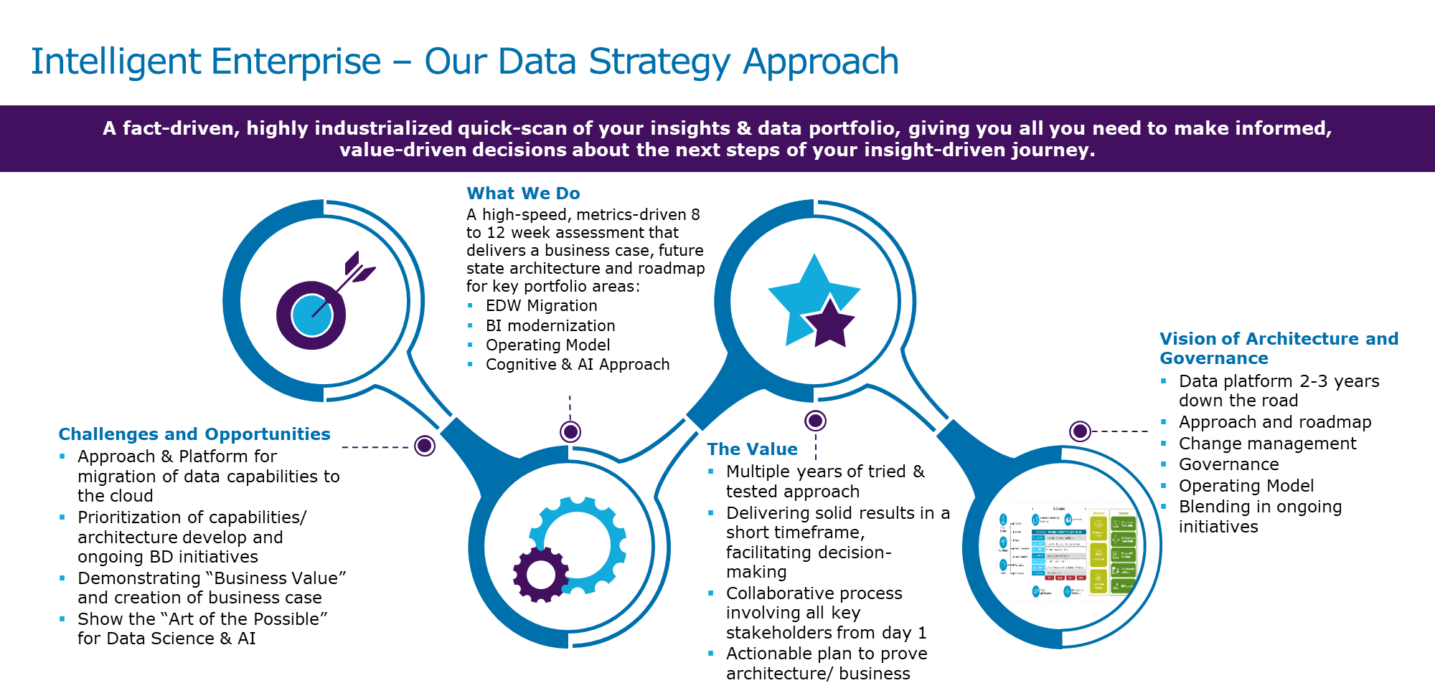

* Capgemini recognizes that each client is different and has unique challenges; as a result, our assessments are tailored to the client and not a one-size-fits-all strategy. We will tailor the Intelligent Enterprise engagement to be focused on National Grid’s specific requirements with a strong emphasis on building strategic analytic solutions that drive material business value. Capgemini’s Intelligent Enterprise (IE) strategy provides governance of the over-arching framework to enable enterprise-wide, intelligent decision-making and enable insights to be generated from all data and information assets.
* IE allows organizations like the National Grid, to move from a physical to a digital business and delivers the ‘nuts and bolts’ to turn data into actionable insights with a well-defined process and people organization that supports simple decisioning as well as automated actions. We provide a wholistic approach with state-of-the-art architectures and accelerators to design, build, deploy and run analytical solutions for at-scale deployments.
* The initial phase of our Intelligent Enterprise approach addresses program orientation, set-up and establishes the initial strategy for future phases. Capgemini will work collaboratively with National Grid to build out scalable strategic technology direction that aligns to the overall business vision and objectives.

1. Deliverables

During the project the Capgemini delivery team will create multiple artifacts. Deliverables are a tangible object that requires formal review and will be identified in the Agile Plan. A work product is a tangible object (document or code) produced by the project team which does not require formal review but are inputs to the final deliverables and may be managed in Agile backlog user stories. The project will require current state assessment, future state blueprint and transformation building blocks.

* 1. Project Management and Acceptance

During the project the Capgemini delivery team will create artifacts to define the scope, approach and costs of the data transformation journey for the Customer Domain. Deliverables are a tangible object that requires formal review and will be identified User Stories with clear acceptance criteria. A work product is a tangible object (document or code) produced by the project team which does not necessarily require formal review but are inputs to the final deliverables and may be an identified sub-task as a unit of work.

The National Grid and Capgemini Agile project team will work collaboratively with Scrum focused on delivering maximum value against the business priorities in the time and budget allowed.

The key components are:

* Establish Epic(s), Features and Objectives will be submitted to create a backlog and setup up a new Scrum board in Jira.
* User stories (USs) and tasks will be created from the backlog.
* There will be only one Product Owner and Scrum Master.
* There will be only one User Story Owner per User Story (USs).
* USs will include agreed upon acceptance criteria during backlog creation and prior to Sprint launch.
* Units of work and deliverables will move through stages of Ready, In-progress, Completed, Accepted and Done.
* Users will be responsible for completing USs and tasks within the Sprint on time based on estimated story points and Sprint timeline.
* Users will be responsible for scheduling acceptance sessions. Once a USs is accepted and moved to “Done” status, the deliverable is considered accepted.
* Project will be managed in Jira and all artifacts will be stored in Confluence.
* In order to avoid delays in the schedule, Deliverables not reviewed and accepted based on agreed upon criteria within Sprint timeline will be prioritized immediately with National Grid & Capgemini Program Managers. All National Grid’s feedback needs to be addressed and deliverables updated and sent back to National Grid for review and acceptance within 3 business days after receipt.
  1. Epics, Features, Work Products and Deliverables
     1. Work Products

|  |  |  |  |
| --- | --- | --- | --- |
| **EPIC** | **Feature** | **WP#** | **Work Product** |
| **Establish a minimal viable customer data domain remediation transformation roadmap and ROM Cost** | Assess and expand current state materials, challenges and gaps. | WP#1 | Present Project Objectives for client approval |
| WP#2 | Produce a summary of customer service data domain themes, pain points, and gaps |
| WP#3 | Create Current State Assessment (Business) to address themes, pain points, and gaps |
| WP#4 | Create Current State Assessment (Technical) to address themes, pain points, and gaps |
| WP#5 | Create a process flow outlining Customer Journey through key touchpoints, systems and people |
| WP#6 | Create Assessment of Customer Data Maturity to assist in defining current state |
| WP#7 | Build out High Level Data Profile to give view of data quality and remediation efforts |
| Design high-level customer data domain future state. | WP#8 | Build recommendations to address Current State Issues and Gaps |
| WP#9 | Document prioritization of use cases to deliver business benefits |
| WP#10 | Create approach to address gaps in the current state of the Customer Journey |
| WP#11 | Document of prioritization of Customer Data Maturity improvements to apply to the Roadmap |
| WP#12 | A document of Customer Domain Governance Model and Process Recommendations to streamline business processes |
| Develop a data remediation blueprint to produce a minimal viable HLDD logical model, scoping of effort and ROM cost. | WP#13 | Create a catalog of quick wins and long-term benefits to prioritize project initiatives and outline immediate ROI |

* + 1. Deliverables

| **EPIC** | **Feature** | **DL#** | **Deliverable (Description)** | **Acceptance Criteria** |
| --- | --- | --- | --- | --- |
| **Establish a minimal viable customer data domain remediation transformation roadmap and ROM Cost** | Assess and expand current state materials, challenges and gaps. | DL#01 | Customer service data domain stakeholder interview and validation summaries | Summaries will include: data domain themes, pain points, gaps, quotes and notes |
| Design high-level customer data domain future state. | DL#02 | Conceptual Data Models | Logical model for processes 8-10 key touchpoint systems to assess data maturity |
| DL#03 | Conceptual Customer Governance, Process and Data Models | Governance, process and data models that will be applied to National Grid business environment |
| DL#04 | Conceptual Customer Architecture | Conceptual reference technical architecture that will be applied to National Grid business environment |
| Develop a data remediation blueprint to produce a minimal viable HLDD logical model, scoping of effort and ROM cost. | DL#05 | Implementation Plan and Next Steps | A high-level view of a 18 to 24-month project catalogue and quick wins recommendations for immediate business impact |
| DL#06 | HL Scoping level of data remediation effort | HL scoping to produce a minimal viable effort to remediate data within targeted environment |
| DL#07 | HL Resource Plan | HL resource plan to provide an estimation of role types and skills required to implement proposed remediation plan |
| DL#08 | ROM Cost to achieve "North Star" | Rough order of magnitude effort estimates to achieve targeted business objectives for customer data domain remediation |

1. Roles and Responsibilities
   1. Organizational Chart

The following is the conceptual view of the organizational structure for the team that will deliver the solution. Three key project-level resource mappings have been identified as part of this organization chart. These leadership positions within the Capgemini project team will work in close collaboration with National Grid counterparts during the project.

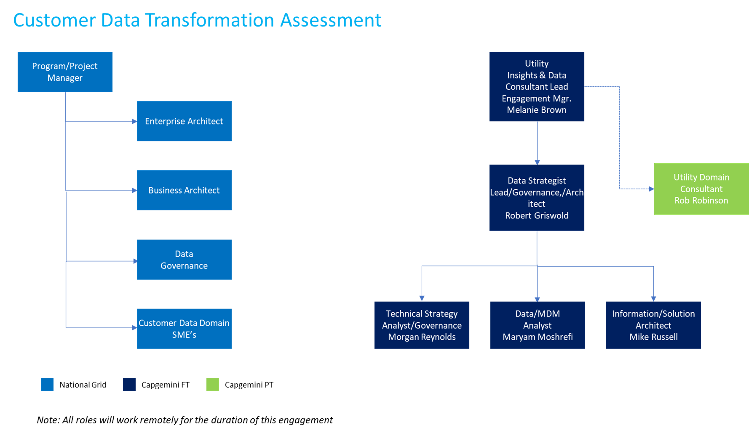

Capgemini team will work directly with the Project Manager to facilitate alignment and coordinate data support, business requirements gathering sessions with Customer Data Domain Stakeholders, Product Owners (applications), Data Management SME’s, and business analyst as needed (see RACI and Assumptions for additional information)

* 1. Project Team

In collaboration with National Grid, the following table identifies key onshore personnel with strong utility sector, data analytical and architectural skills that Capgemini anticipates to staff in selected roles:

| **Role Title** | **Anticipated Role Attributes and Responsibilities** | **Resource**  (dependent on start date, subject to change) |
| --- | --- | --- |
| Utility Insights and Data Consultant | 20 + yrs. Data Management, Analytics and Compliance and Utility Technology Operations Strategic Planning and Execution. Spearheaded overarching enterprise solutions and leads the overall data ecosystem transformation solution from building blocks maturity, pre-implementation to optimized environment– Build, Develop and Design Data Trust Artifacts, MDM governance, Data Management BMS Standards compliance, Utility Data Modeling and Six Sigma related tools and processes. | Melanie Brown |
| Utilities Domain Consultant | 20+ yrs. Utility Consultant providing expertise on data flow process, Systems and IT Capabilities requirements alignment, data streams dependencies and value-based assessments. Will work closely with data SME/Lead to develop assessment on SIPOC work effort | Rob Robinson |
| Data Strategy Lead (MDM, Data Governance and Architect) | * Overall Lead for the strategy engagement * Manage strategy engagement day to day * Facilitate workshops and working sessions * Project management, status reporting, issue & risk management * Lead Business/ Business Architecture workstream & components * Oversees functional portion of deliverables * Develop estimates/ business case | Robert Griswold |
| Information/Solution Architect | * Lead technical workstream/ future state architecture definition * Coordinate Architecture workshop * Conduct interview/ working sessions * Contribute to overall approach/ solution architecture * Develop technical approach/ technical architecture * Detailed design/ documentation of proposed solution | Mike Russell |
| Technical Strategy Analyst (Process, Data Governance & Quality) | * Support planning for architecture workstream * Contribute in the development of estimates/ business case * Support technical architect in day-to-day work * Support Architecture workshop * Analysis of customer end to end journey * Support interviews/ working sessions * Contribute to deliverables and work products * Support technical architect in development of future state architecture | Morgan Reynolds |
| Data Analyst (MDM, Data Governance & Quality) | * Conceptual data models * Analysis of customer end to end journey * Data Profiling | Maryam Moshrefi |

In collaboration with Capgemini Team, the following table identifies key National Grid primary selected roles:

| **National Grid Role Title** | **Anticipated Role Attributes and Responsibilities** | **Resource** |
| --- | --- | --- |
| Program Manager | Customer Domain Management Oversight | As assigned |
| Project Manager | Maintains and monitors project plans and project schedules. Responsible for ensuring the project remains on track for on time deliverables. Communicates issues to Program Manager and NG team. | As assigned |
| Customer Data Team Lead | Partners with Capgemini Team leading the overall data ecosystem transformation solution, MDM governance, BMS Standards compliance. Responsible for the success of the NG Team’s participation and facilitating Customer Domain SME’s. | As assigned |
| Governance Data Lead | Partners with Capgemini Team responsible for Data Governance | As assigned |
| Architects | Working in collaboration with the Capgemini, architects will assist in designing data continuity and accessibility strategies reflective of business needs and technology alignment Build sound data structures that bridge business strategy and information technology execution. Configure transformed data assets that leverage previous discovery phase findings and data strategy recommendations. Manage data complexity and the integration of enterprise level data delivery. | As assigned |

* 1. Deliverables RACI Matrix

The terms used in the below RACI table have the following meanings:

R: RESPONSIBLE

Takes primary responsibility for the quality, completeness and punctuality of the assigned task. The party with the “R” responsible role produces the main activity deliverables and obtains approval.

r: RESPONSIBLE

Party(ies) with secondary responsibility for performing the activity/creating the Deliverable or Client Output. These party(ies) will be expected to create part of the Deliverable or action under the direction of the party with “R” responsibility in the RACI Table or may assist with the activity or task.

A: ACCOUNTABLE

Validate or confirms the task results; Approval Sign off, if applicable. The party having the "A" role may also assign approval responsibility to the appropriate resources.

C: CONSULT

Provides Expertise, so that correct advice is given to drive an appropriate decision / solution.

I: INFORM

Is informed about the task content and uses the information to correctly synchronize activities under their responsibility.

The following table defines responsibility and accountability between the various parties and organizational groups involved in delivery:

|  |  |  |
| --- | --- | --- |
| **Engagement/Project Management Activities** | **National Grid** | **Service Provider** |
| Establish Capgemini team; mobilize and manage resources | C,I | A, R |
| Establish National Grid team | A,R | C, I |
| Confirm stakeholder involvement | A,R | C,I |
| Identify risks and mitigation strategies | A,C,I | R |
| Create Product Backlog | A,C,I | R |
| Conduct Backlog Refinement and Sprint Grooming | A,r,C,I | R |
| Conduct Daily Stand-ups | A | R |
| Accept User Stories and task deliverables | A,R | r,I |
| Conduct Sprint Review | A | R |
| Conduct Sprint Retrospective | A,r | R |

|  |  |  |
| --- | --- | --- |
| **Deliverables** | **National Grid** | **Service Provider** |
| PowerPoint Presentations and/or PDF formats will be used as a deliverable readout and formal documentation | A, C, I | R |
| Gather and establish business, functional & technical requirements | A,C,I | R |
| Design and build data transformation journey, scope and costing structure | A, C, I | R |

1. Proposed Assessment Timeline

It is estimated that the Services specified in this SOW will require a total of 8 business weeks to perform. The anticipated start date for the Services is to occur during June 2020 and commence for (8) weeks.

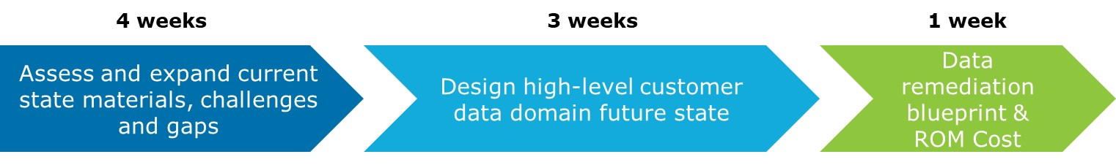

*[The Remainder of This Page Is Intentionally Left Blank]*

1. Estimated Costs

The Services (including deliverables) under this SOW will be performed **under Innovation Funds on a fixed-fee** basis for $67,122 (excluding expenses) and will be payable per the below schedule:

|  |  |  |  |  |
| --- | --- | --- | --- | --- |
| **Milestone #** | **Phase** | **\* Anticipated Invoice Date** | **Anticipated Invoice Amount (USD$)** | **Acceptance Criteria** |
| 1 | Mobilization/Kickoff, Material Review | 6/22/2020 | $27,129 | The Customer Project Manager's acceptance of the Deliverables described in this Call-Off Agreement. |
| 2 | Current State Assessment | 7/31/2020 | $13,564 |
| 3 | Future State/Effort Scoping and ROM Cost | 8/10/2020 | $27,129 |
| Project Labor Cost (Fixed Rate) | | | $67,822 |
| Project Expenses (actual incurred, monthly basis) | | | $0.00 | Payment will be made upon the Customer Project Manager's approval in accordance with this Call-Off Agreement |
| Total Project Cost (not-to-exceed) | | | $67,822 | |

* 1. Resource Staffing Table

|  |  |  |  |  |  |  |  |  |
| --- | --- | --- | --- | --- | --- | --- | --- | --- |
| Resource | Skill ID | Skill Description | Role | Min. work related experience (years) | No. Resources | # Days | US: Onsite USD/Day Rate | Resource Cost |
| Robert Griswold | ADAM  42-P | Information/Data Management, Decision Support, Remediation | Strategy Lead - MDM, Data Architect / Governance | 15+ | 1 | 47 | $1,256.00 | $59,032.00 |
| Robert Robinson | GMC | Organization and Operating Model | Utility Domain Consultant | 20+ | 1 | 3 | $2,930.00 | $8,790.00 |
| Total |  |  |  |  |  |  |  | $67,822.00 |

National Grid shall reimburse Service Provider for travel, meals, and lodging in connection with overnight stays related to this Project as set forth below. National Grid shall pay such expenses for reasonable hotel, meals, direct air and rail transportation charges (at cost). All travel shall be economy or coach class. No other expenses are reimbursable. Expenses are estimated to be $0.00. Expenses shall be billed on a monthly basis.

Any delay in the completion of any applicable invoicing milestone that is not attributable to a failure or delay by Service Provider will not impact the invoicing or payment related to such milestone. Thus, for example, if a milestone is delayed due to factors beyond Service Provider’s control (such as a failure by National Grid or its vendors or contractors or other parties to perform their obligations in connection with the Project; the failure of software or hardware to perform as expected; or the failure of any of the assumptions established in this SOW), then the applicable milestone-based fee shall be invoiced and become payable on the originally projected completion date for the milestone. Any affected milestone date shall be extended according to the change control procedures of the Agreement.

*[The Remainder of This Page Is Intentionally Left Blank]*

1. Governance
   1. Governance Structure  
        
      The following Governance Structure that will provide a system of escalation and control to drive decisions and maintain accountability during the performance of delivery services as outlined in this SOW. The figure below outlines the relationship and responsibilities from day-to-day oversight to executive review.

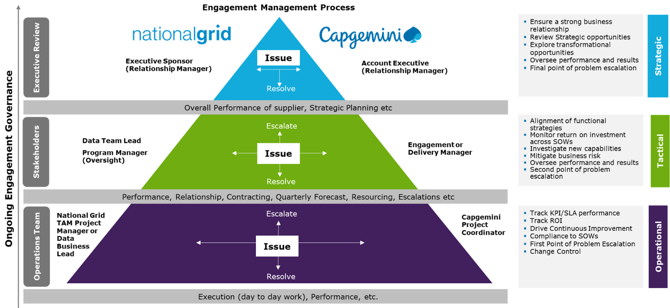

* 1. Governance Responsibilities

Co-Collaboration National Grid Project Manager, Business Lead and Capgemini Project Coordinator

* Schedule and facilitate meetings with stakeholders
* Coordinate activities with Stakeholders and Implementation workstreams
* Manage resource dependencies
* Support provisioning data access and documentation
* Assign and track work progress in collaboration with Capgemini delivery team
* Provide status reports as required
* Coordinate, obtain and promptly provide information, data, decisions and approvals, within five (5) business days of submitting deliverables for review unless both parties agree to an extended response time

The National Grid Program Manager will:

* Provide program oversight
* Provide support as needed to designated Project Manager or Data Team
* Administer provisioning credentials/badges, laptops, remote access for the Capgemini Team

The Capgemini Engagement/Delivery Manager and Project Coordinator will:

* Provide additional resource to support National Grid Program or Project Manager coordination activities
* Establish and maintain Scrum activities inclusive of all milestones, sprints, stage gates, critical meetings and coordination with SME’s
* Provide weekly status report to include a forward-looking schedule status, deliverable progress, open issue monitoring and stakeholder engagement
* Conduct internal meetings to monitor critical path activities and escalate issues to National Grid Team as required
* Establish governance around issue and risk management and will drive timely resolution of issues and mitigation of risks
  1. Change Control Process

Change control process is governed by the Framework Agreement related to Applications Development and Applications Maintenance Services, dated December 17, 2018 (“Agreement”), between Capgemini America, Inc. (“Capgemini”) and National Grid USA Service Company, Inc. (“National Grid” or “Client”).

Proposed changes to scope must go through a comprehensive and rigorous change control process that seeks to ensure that all changes are necessary and minimize the impact on timelines and costs. To initiate the scope change process, Capgemini will submit standardized documentation that outlines the specific change being requested, the justification for the change, and the impact of the change on timelines, cost, and any dependencies or assumptions.

* + 1. Change Criteria

Items expected to be eligible for change control process, include, for example:

* Any requested change in work that leads to creation or deletion of Deliverables into any milestones
* Any change in design functionality that leads to new functional and technical requirements
* Any change to milestone scheduling relative to the initial scheduling agreement  
  + 1. Communication

Communication is governed by the Framework Agreement related to Applications Development and Applications Maintenance Services, dated December 17, 2018 (“Agreement”), between Capgemini America, Inc. (“Capgemini”) and National Grid USA Service Company, Inc. (“National Grid” or “Client”).

Once supplier has submitted standardized documentation, potential scope changes should be thoroughly documented in the Project Change Log, including a detailed description of the proposed change, the originator of the change, the date the request was initiated, and estimated impacts on schedule and cost. Once the review has been performed, the Project Change Log should be updated to show the record of change review, the party responsible for the review of the proposed change, and the final outcome (approval / denial) along with the decision rationale.

The Project Change Log will be maintained by National Grid Program Manager and will be made available to all relevant stakeholders to ensure cross-work stream coordination and alignment of the change management process. Product Owners should be copied on all change requests and are expected to review and communicate any concerns or issues identified to the National Grid Program Manager.

Upon review of submitted change requests, the National Grid Program Manager is responsible for sharing decisions and feedback to relevant stakeholders, subject to its obligations of confidentiality with respect to any Capgemini Confidential Information.

* + 1. Change Control Requirements

In connection with the project, Capgemini will be required to submit a change of scope request for any potential scope change that will deviate from the agreed upon original scope of work. The request should include the proposed change, rationale, and potential estimated impact to the overall project scope, timeline, and budget.

* + 1. Risk and Issue Management Plan

Risk and Issue Management process is governed by the Framework Agreement related to Applications Development and Applications Maintenance Services, dated December 17, 2018 (“Agreement”), between Capgemini America, Inc. (“Capgemini”) and National Grid USA Service Company, Inc. (“National Grid” or “Client”).

* + 1. Risk Management Process

The National Grid Risk Management process defines the approach to identifying, documenting, monitoring and controlling Project risks initially and as the Project evolves. The iterative process is designed to promote identification of relevant risks and provide a process through which all identified risks are managed through mitigation, transfer or Acceptance until they can be closed.

In this context, a risk is defined as an item which may adversely affect the project in one or more dimensions (scope, schedule, financial, company reputation, regulatory, environmental, or health and safety) and jeopardize full realization of Project goals. The National Grid Program Manager has primary responsibility for executing this process and for risk management for the project. Capgemini will proactively identify and manage risks within its own scope of work and provide regular updates to the National Grid Program Manager. Issue Resolution Process

* + 1. Issue Management Process

Issues are current problems facing the project which have the potential for negative impact on project cost, schedule, scope, safety or other objectives and require prompt action to prevent or minimize the negative impact. The approach to Issue Management is similar to that for Risk Management, and the process is described below.

**Issue Communication and Reporting**

Issues will be communicated using the same process as outlined in the risk section above. All issues classified as Critical and other issues as needed, at the discretion of the Project Manager will immediately be escalated to the VOLT Program Manager, who will determine if immediate notification and involvement of the National Grid Executive Sponsor is warranted.

* 1. Personnel Replacement Process

Personnel replacement is governed by the Framework Agreement related to Applications Development and Applications Maintenance Services, dated December 17, 2018 (“Agreement”), between Capgemini America, Inc. (“Capgemini”) and National Grid USA Service Company, Inc. (“National Grid” or “Client”).

1. Assumptions
   1. Key Assumptions and Dependencies

Service Provider has relied on the assumptions stated below in pricing, planning, and determining its approach to the Services. National Grid acknowledges that project duration and cost to National Grid under this SOW may be adversely affected if any project assumptions are changed or not realized, or if there are any additional elements or assumptions.

|  |  |
| --- | --- |
| Source Data / Repositories | |
| **Assumption** | **Explanation** |
| **Source Data Availability** | National Grid served programs will provide current pre-cleansed and production level data to support development, system testing, performance testing, and user acceptance testing activities.  No customer or personally identifiable information or sensitive personal information will be accessed or used for this project. There are no Customer Compliance Directives for the purposes of this SOW. The addition of any Customer Compliance Directive shall require the mutual written agreement of the parties.  To the extent that the parties have access to personal data subject to the EU Data Protection Directive or General Data Protection Regulation, the statutory and regulatory requirements applicable to such data shall apply and Service Provider shall handle receipt of such data in accordance with the Binding Corporate Rules of the Service Provider Group.  Capgemini will work with National Grid DBA’s, SME’s, contractors and the application vendors, if needed, to develop a data refresh strategy that will allow fresh production data into core systems while retaining test data. |
| **Firewall/Security** | Firewall/security access to National Grid’s servers for the Service Provider support team will be the sole responsibility of National Grid. Firewall issues on Service Provider network side will be the sole responsibility of Service Provider. |
| **Accuracy** | Service Provider shall have no obligation independently to verify the accuracy or completeness of the information provided by National Grid or its agents. Service Provider’s services are informational and advisory in nature, and National Grid has full responsibility for the use of, and the results obtained from, the services and any deliverables. |
| **Disaster Recovery** | National Grid shall be responsible for the back-up of any National Grid Data. |
| **Testing** | Capgemini data team will provide the oversight and direction for build, design, configure and test of MDM data trust elements and relationship mapping. Capgemini will require access and National Grid resource support to build the test bed(s) but will be responsible for the test environment once built. |

|  |  |
| --- | --- |
| Required support from National Grid leadership to execute this project | |
| **Assumption** | **Explanation** |
| **National Grid Leadership/SME’s** | National Grid will provide timely access to the resources required to complete the activities defined within this proposal. These individuals are to include key users, access to the staff of the current provider, and executive management as required by the Service Provider project team. National Grid will encourage staff and management to attend meetings and address issues raised on a timely basis. National Grid will provide assistance with scheduling, communication, and other logistics associated with all meetings. National Grid will perform its required tasks and make decisions in a timely manner so as not to delay Service Provider.  National Grid will have the necessary Subject Matter Specialists (SME) available to support project activities either at Waltham, MA or via teleconference. |
| The activities under this SOW involve a collaborative effort by the parties and Service Provider will rely upon National Grid’s participation in such activities. National Grid acknowledges that the results of the services will be based, in part, upon the information, materials and guidance provided by National Grid. |
| **Data Repositories** | National Grid will see Capgemini has the necessary authorization to access data repositories and streams as needed, for Capgemini to perform the services contemplated hereunder. No customer data or personal identifiable data will be required or accessed during this project. |

IN WITNESS WHEREOF, the undersigned, acting through their authorized representatives, have signed this SOW to be effective as of the SOW Effective Date.

|  |  |  |  |
| --- | --- | --- | --- |
|  | |  | |
| **Capgemini America, Inc.**  By: _______________________________  Print Name: Eric Jacobs ______  Title: Account Executive ______ | **National Grid USA Service Company, Inc.**  By:  Print Name:  Title: | |